Dear Parents and Caregiver

Welcome to the final newsletter of the term. The Term has been full of both joy and challenge. Our children are certainly ready for a break.

It has been wonderful to see so many children make the most of the sporting opportunities that have been on offer. The Sports Committee have done a superb job. A big thank you to all of you who have supported our participation. What a wonderful day we had on Sunday for the Shore to Shore. Congratulations to all our children and their families who participated in the event.

Over the term it has been amazing to see the number of parents being involved in school life with their children. We really do value your partnership as it does take ‘a village to raise a child’.

I have included an article for you to read which I have also shared with our staff ‘Raising Kind Children’.

Mrs Collins who has been away on sick leave has resigned her position. We wish her well.

Mrs Tess Blockley will be taking over the role of Team Leader with the support of Mrs Carla Veldman.

We welcome Miss Stephanie Brook to the Year 3/4 Team. Miss Brook has been working in the Year 3/4 Team over the past two weeks. We are excited to have her join the team.

I wish you all safe travel over the Easter/School holiday break.

Kind Regards

Raewyn Matthys-Morris

Principal

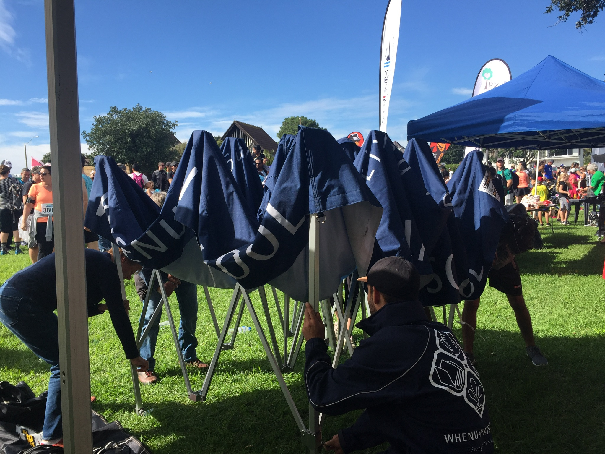

**Assembly**

**Thursday 13th April**

9.30am – ANZAC Assembly



**April 13th**

**End of Pokemon Season**

Ice Block day

Last day of Term 1

**April 25th**

ANZAC Day Parade

**May 1st**

First day of Term 2

Uniform Sale

9.15am Powhiri to welcome new Students and Staff

Final date for ICAS Science Comp entries, forms and fees

**May 3rd**

Closing date for 2017 Great Kiwi Science, English and Maths Competition entries

Data Sharing Conversations

* classes cease 12.30pm

* buses depart 12.40pm

* interviews start 1.20pm

**May 11th**

Math-a-thon

**May 16th**

6.00pm Parent Information Evening (Years 5-8 students)

**June 16th**

Quiz Night

**June 27th**

Junior Tough Guy and Girl Challenge

**Principal's Messa**



**Prinicpal’s Digest , sVolume 23 Number 14**

**Raising Kind Children**

Families foster kindness and respect at home by setting expectations for manners, sharing, and helping with chores. And families *hope*, often with a tinge of worry, that children will continue those behaviours when parents and caregivers aren’t nearby: in school cafeteria, at a friend’s house, or on Instagram and Snapchat. But guiding children to be empathetic and ethical in their independent lives – even when no one is looking – can be more intentional than that.

**Startegies for teaching children to think ethically, care about the people around them, and create positive change in the world.**

**To guide ethical thinking:**

* Discuss ethical dilemmas you have encountered at work, with friends, or running errands. Ask your children what they would have done in that situation.
* Talk about ethical dilemmas your children might face in the classroom, at lunch, or during recess, Brainstorm and role-play possible solutions.
* Encourage your children to see conflicts from another person’s perspectivee. Discuss ways they can compromisee between their needs and those of others.

**To foster concern for others:**

* Encourage your children to really *listen* to siblings or peers when they are upset, especially if they don’t initially understand that person’s views.
* Ask children to consider the perspective of people they don’t usually talk to: a new student at school, a student who is often teased, a student experiencing family trouble, or a student of a different race or religion.
* Discuss hardships you see on the news, and talk about the experiences, challenges, and feelings of people who live in different places around the world.

**To teach children to be change-makers:**

* Inspire children to take action around issues that affect them and their peers, such as school uniform policies, transgender student’s rights, or the healthfulness of school lunches.
* Distinguish the importance of “doing with” others from “doing for” others. Encourage children to respond to community problems by working with and listening to a diverse group, rather than spearheading new initiativeswithout any guidance. This is particularly relevant for high school students seeking community service opportunities. Parents can guide children to take a richer, more meaningful approach to volunteer work.
* Model that communal approach and the importance of service. Volunteer together at a charity event or set aside a day as a family to donate unwanted clothes and toys.



*Acknowledgement: Leah Shafer in Usable Knowledge 27 February 2017*

**ANZAC Assembly 13 April – 9.30 am** A special ANZAC Assembly is being held on Thursday April 13th (the last day of term) and we encourage parents to join us on this special occasion.

Our Year 8 Prefects will be our MCs and a representative from each class will be laying a wreath, which their class have all made together.

It will be a formal occasion with special readings, representatives from the Air Force Base and a Bugler.

Parents are welcome to stay for tea/coffee and biscuits after the formal celebrations.

**Anzac Day Parade 25 April – 10.30am** We would like to extend an invitation to you from the Hobsonville RSA to attend the ANZAC Day Parade and Service on Tuesday April 25th. The parade starts at Hobsonville School at 10.30, finishing at Hobsonville RSA. We will be laying a

wreath on behalf of Whenuapai School. Students must wear their school uniform in the march.





**WET UNIFORM -** A lot of rain this week has resulted in a number of very wet and muddy children requiring a change of uniform. Limited spare uniform is held at the office for emergencies, all of which has been given out over the past two days. Where possible it would be appreciated if a change of uniform could be brought to school and left in your child’s bag.

**Additionally, can all borrowed uniform please be returned to the School office.**

**Data Sharing Conversations - Wednesday May 3rd**

Normal class times for the whole school will cease at **12.30pm**

Buses will be leaving school at **12.40pm**

On Wednesday May 3rd you are invited to attend ‘Data Sharing Conversations’ with your child’s teacher, your child and yourselves. These conversations are predominately for **Years 4-8 students,** however parents of our Year 0-3 students are welcome to take this opportunity to meet with your child’s teacher also.

Ten minute conversations will be held in your child’s classroom starting at 1.20pm and concluding at 7.00pm, teachers will have a break between 5.00 – 5.30pm. Please book your interview online at: [www.schoolinterviews.co.nz](http://www.schoolinterviews.co.nz)  using the School code: c8en2

School will remain open but normal **classes for the whole school will stop at 12.30pm** and **buses will leave at 12.40pm**. Please be aware that there will be **no buses at 3pm**.

The Skids and Whenuapai After School Care facilities have been informed. It is parents/caregivers responsibility to make the appropriate arrangements with these two providers.

**Skids** - 021 174 8473 **WASC** - 417 7000 Ext 7882

Should you require your child to stay at school until 3.00pm please complete the form which was sent home with your child and return to your child’s teacher before 13 April 2017.

**Notice Board…**



**ICAS Competitions**

A reminder to those students wishing to enter the 2017 ICAS Science competition.

The official closing date for the Science entries is Tuesday the 2nd of May.

Completed entry forms and fees will need to be received by the School Office by:

**Monday - 1st of May**

**(first day of Term 2)**

An email reminder will be sent to parents in the second week of the school holidays.

**2017 Great Kiwi Science, English and Mathematics Competitions**

Please be aware that the notice provided by the University of Canterbury provided an incorrect return date for entries (a date in the School holidays).

We have confirmed the final date for entries and fees is:

**Wednesday - 3rd of May**

An email reminder will be sent to parents in the second week of the school holidays.

**Parents Evening - Year 5-8 Students**

Parents of students in Years 5 - 8 are invited to attend a Parents Information Evening for our Health programme running in Term 2:

**Tuesday 16 May 2017 at 6:00pm (duration - 90 mins)**

More information on the Parents evening will be provided in Term 2.

​

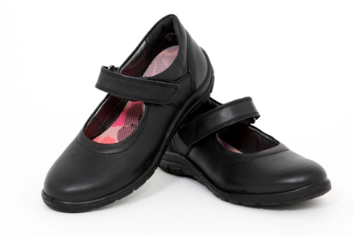

**Lost Property**

It’s hard to believe we are nearly at the end of Term 1.

Over the term our lost property box has grown even bigger and it would be great if some of these items could be returned to their rightful owners.

The lost property box is located in the foyer beside the uniform shop at the back of hall.

Parents are welcome to check this at any time for missing items.





**Health**

The weather is changing and with this has come the bugs. Last week we were informed by parents of a case of bronchitis, several cases of a sore throat and a number of students with a stomach virus.

The New Zealand health site has information of a number of conditions or illnesses that can be searched to help families understand what their child may have. They recommend that a child should stay at home until they are well and for **48 hours** after the last episode of diarrhoea or vomiting.

[**www.health.govt.nz/your-health/conditions-and-treatments**](http://www.health.govt.nz/your-health/conditions-and-treatments)



**Sport**

**Soap Box Derby**

Our wonderful team raced on Sunday the 2nd of April and we made it to the semifinals. The times were down to the difference between 1000ths of a second.

One of our racers got the fastest time in the heats and all drivers did well and had a fun day.  It was a great effort from everyone involved. We are all looking forward to next year already.

There will be a fund raising sausage sizzle next term to go towards the Rotary International charity who organizes the Soapbox Derby event.

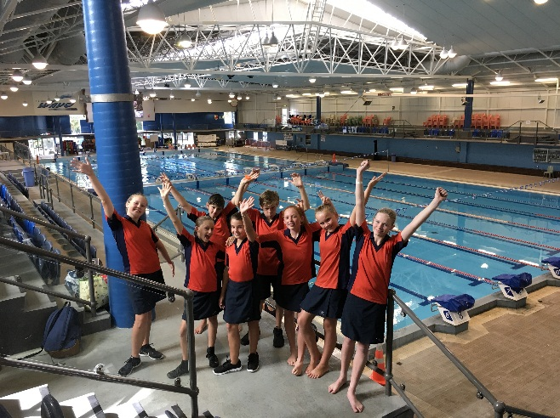**Swimming**

Last week we took 8 children to the Norwest Swimming champs. Congratulations to Isla Brain who came 1st in Year 8 girls 50m freestyle, breast stroke, butterfly, and back stroke. She also came 1st in the girls 100m freestyle. Congratulations to Charlotte Graham who came 4th in the Year 7 girls freestyle. Our Year 7/8 girls came 2nd in the medley relay and the Year 6 team came 4th in the mixed freestyle relay.

Congratulations to Isla and Charlotte who are competing at the Auckland Champs this week.

**Shore to Shore**

A group of keen students and teachers participated in the 5km Shore to Shore fun run/walk on Sunday 9th of April. A great morning was had by all participants enjoying some much needed Auckland sunshine.

    

**Basketball**

We are almost half way through the first season of basketball at the YMCA and our teams are growing stronger each week with the support and guidance of their coaches. Each week brings new opposition to face and new lessons to learn on skills, team work and community. We model team work and community to our children. Our school is good at this and the sports teams at our school are fortunate enough to have a PTA that stands behind us. This past Sunday the PTA joined forces with basketball families and we fundraised, selling food and beverages at the Whenuapai Half Marathon. Funds will go towards sports uniforms and new basketball systems at our school. The generosity of the local community was wonderful with several people paying their money forward to buy others food and beverages. We thank Paula and her team for supporting us in this initiative and to all the basketball and PTA parents who gave their valuable time to help man the stand.



Last week the Whenuapai Fireballs faced the MV Warriors and beat them 10-6. The Slammers lost their game to the Huapai Thunder.  The Flyers faced MV Wizards. They played a tough game but lost. The Thunder faced some heat on the court and were outplayed by a formidable Hobsonville Heat and lost their game.  Our little foxes lost their game as well against the St Paul's Shooting Stars. Sometimes we win sometimes we learn (lose), but in every game we master our skills and we thank our opposition who challenge us and push us beyond our limits so we are better in our next game.  Our stand out players last week were Jayden, Aston, Luke and Jaime. Well done to them for shining on the courts.



**Athletics**

Jayda, one of our amazing Year 3 students recently ran in the Auckland Junior Athletics Champs. Jayda came 1st for her age for the 60M 7 year old girls and 2nd for the 100M for her age. Jayda runs for Massey Club. We are looking forward to hearing about more of her successes in the future.

**PTA News**

Upcoming events include:

**Ice block day 13th April**

**Uniform sale 1st May - 5th May 8.30-9.00am**

**Entertainment book letters to go home on the 1st May**

**Math-a-thon 11th May**

**Quiz Night 16th June**

**Ice block day** notices have gone home. Ice block day is Thursday 13th April. If you are missing yours the office has spares.  Money is to be in by the 7th April please as we need to order the ice blocks.  Ice blocks are $2.50.

The **second hand uniform sale** will consist mainly of jumpers, which will be sold for $5.00 each.  Tables will be placed outside of the School office each day from the 1st - 5th May from 8.30am to 9.00am.

**Entertainment Book** letters will be sent home next term, with your child.  If you wish to purchase a book, the letter has all the information regarding digital and physical copies and how to order.  The School benefits from each sale, as a portion from each book sold comes back to the School.

**Math-a-thon** information has gone out this week.  This is a very exciting event as we are fundraising for the new bike track that is going to be installed at School. More information on the bike track is on the School’s website.

Our **Quiz & Auction** evening is happening on Friday 16th June. This is an adult only event being held in the school hall. There will be limited seats available so save the date and get in early when the notices go out next term. At this stage we are looking for donations from family and friends of the School. The items we are hoping for are items that can be used to make up hampers to raffle off as well as items that can be used as silent auctions. If you having anything you wish to donate please contact Ruth Waller by email [rvwaller@gmail.com](mailto:rvwaller@gmail.com) or drop items/vouchers etc. into the School office. We are also keen to hear from anybody who may wish to sponsor a table as advertising and can discuss details with you further. Again please feel free to contact Ruth via email if this is something you may be interested in.

**School Cycling Program**

A **School Cycling Program** is coming to Whenuapai School as part of the School curriculum.

For more detailed information please check out our website: <http://www.whenuapai.school.nz/>

The aim of the program is to enable our students to develop into competent cyclists with the skills, knowledge and experience to safely ride on New Zealand’s roads and off road trails.

A significant amount of work is already underway. The school has purchased new bikes and helmets and we have funding for a secure storage facility and the first of 3 cycle tracks. Coaching training has taken place and the first cycle session has been completed. This is an exciting development for our School and Community.





**Music**

**Piano /Keyboard**

There are two vacancies for piano/keyboard lessons at School.

Please contact Diane Hunn on 021 653386 for further information.

**Musiqhub Band Programme and “Have a Go” day:**There are still spaces available for children in Year 2 and older who would like to learn clarinet, trumpet, flute, ukulele, snare drum or saxophone. Please note that not all instruments are available to every year level. If you are interested in finding out more, please contact Joanne Slagel on 027 3408 398 or [joanne.slagel@musiqhub.co.nz](mailto:joanne.slagel@musiqhub.co.nz)

**SUPPORT GROUP**

Parents of Children with learning / behavioural needs

Hi my name is Vivienne – I am starting a support group for parents who have children with learning or behavioural needs. I have an eight year old son who has ASD/ADHD and Dyspraxia.

If you are interested or would like to know more please email Sharron Buer, [sharronb@whenuapai.school.nz](mailto:sharronb@whenuapai.school.nz). Sharron will be happy to pass your contact details on.



The 13-Storey Treehouse

Live at the Bruce Mason Centre these school holidays.

**Tue 18 – Sat 22 April**

Andy Griffiths’ and Terry Denton’s best-selling book *The 13-Storey Treehouse* has been made into a play. This April, be on the lookout for flying cats, a mermaid, a sea monster, an invasion of monkeys AND a giant gorilla; all brought to life on stage with a seriously funny cast and magical moments of theatrical wizardry.

For more information go to: <https://www.aucklandlive.co.nz/show/the-13-storey-treehouse>





Auckland's newest technology centre! Brain Play is a company that aims to introduce students aged 5 - 15 of all abilities to technology fields such as coding/computer programming and robotics.

Classes held at Albany Junior High School from 3:30 – 6.30pm every weekday and in school holidays.

Visit [www.brainplay.co.nz](http://www.brainplay.co.nz/) or call 0275096168 to book your **free trial**.

**KEY CONTACTS**

**Principal** – Raewyn Matthys-Morris

[rmatthys-morris@whenuapai.school.nz](mailto:rmatthys-morris@whenuapai.school.nz)

**Deputy Principal** – Carla Veldman

[cveldman@whenuapai.school.nz](mailto:cveldman@whenuapai.school.nz)

**Board of Trustees**

[bot@whenuapai.school.nz](mailto:bot@whenuapai.school.nz)

**PTA**

[pta.whenuapai@gmail.com](mailto:pta.whenuapai@gmail.com)

**SKIDS After School Care**

[whenuapai@skids.co.nz](mailto:whenuapai@skids.co.nz)

**ONLINE PAYMENTS**

Should you have any queries please contact Mr Tony Hitchcock by email; [thitchcock@whenuapai.school.nz](mailto:thitchcock@whenuapai.school.nz)

Bank Account details: 123085 0494188 00

Reference: Students name

Details: what activity the payment is for

If you pay online for more than one activity or pay for more than one student and various activities, please email Tony indicating what the payments are for.

|  |  |  |  |  |  |  |  |  |  |  |  |  |  |  |  |  |  |  |  |  |  |
| --- | --- | --- | --- | --- | --- | --- | --- | --- | --- | --- | --- | --- | --- | --- | --- | --- | --- | --- | --- | --- | --- |
| **Community Information…**  **Feedback sought on Whenuapai draft plan change**  A draft plan change to rezone large areas of Whenuapai for housing and business development opens for public feedback on 10 April.  The plan change is the next step in urbanising this largely rural area of Auckland after the approval of a two-stage structure plan in September 2016.  Once the plan change is adopted, stage one of this development opportunity will be built over the next 10 years. Infrastructure is already in place or will be built for about 5000 dwellings and 93ha of business land that will provide for nearly 3000 jobs.  A second plan change will be necessary for stage two of the project. Development in stage two cannot start until additional infrastructure – principally the Northern Interceptor (a wastewater pipe), and highway improvements – are completed.  Public feedback closes on 14 May.  You can find more information on the plan change at the following locations:   |  |  |  | | --- | --- | --- | | **Event** | **Date and Time** | **Venue** | | Drop in information session | Tues 11 April 7.30pm-9.30pm | Whenuapai Village Hall | | Drop in information stall | Sat 29 April 10.00am-2.00pm | Countdown Northwest | | Drop in information stall | Sun 30 April 10.00am-2.00pm | Countdown Hobsonville | | Drop in information stall | Tues 2 May 7.00am-10.30am | West Harbour ferry service from Hobsonville Marina | | Drop in information session | Thurs 4 May 7.30-pm 9.30pm | Hobsonville Primary | | Drop in information stall | Sun 7 May 9.00am-1.00pm | Hobsonville Farmers Market | |